
nSRM Institute of Science and Technology
Mode of Exam
OFFLINE
College of Engineering and Technology
School of Computing
DEPARTMENT OF COMPUTING TECHNOLOGIES
SRM Nagar, Kattankulathur – 603203, Chengalpattu District, Tamilnadu
Academic Year: 2021-2022 (EVEN)
Test: CLAT-1 Date: 4-4-2022
Course Code & Title: 18CSC205J: Operating systems Duration: 1 Period
Year & Sem: II & IV Max. Marks: 25 Marks

Course Outcomes (CO): |  |  |  |  |  |  | At the end of this course, learners will be able to:
CO-1 : |  | Express the fundamental concepts in operating system
Program Outcomes (PO)
1 | 2 |  | 3 | 4 | 5 | 6 |  | 7 | 8 | 9 | 10 | 11 | 12 | PSO
Engineering Knowledge | Problem Analysis |  | Design & Development | Analysis, Design, Research | Modern Tool Usage | Society & Culture |  | Environment & Sustainability | Ethics | Individual & Team Work | Communication | Project Mgt. & Finance | Life Long Learning | PSO - 1 | PSO - 2 | PSO – 3
3 |  |  | 3 |  |  |  |  |  |  |  |  |  |  | 2

Part - A
(5 x 1 = 5 Marks)
Instructions: Answer all
Q. No | Question | Marks | BL | CO | PO | PI Code
1 | In Unix, Which system call creates the new process?  - Fork  - Create  - New  - None of the mentioned | 1 | 1 | 1 | 1 | 1.6.1
2 | What is the ready state of a process?  - When process is scheduled to run after some execution  - When process is unable to run until some tasks has been completed  - When process is using the CPU  - None of the mentioned | 1 | 1 | 1 | 1 | 1.6.1
3 | A Process Control Block (PCB) does not contain which of the following?  A. Code  B. Stack  C. Bootstrap program  D. Data | 1 | 1 | 1 | 1 | 1.6.1
4 | What is inter-process communication?  - Communication within the process  - Communication between two processes  - Communication between two threads of same process  - None of the mentioned | 1 | 1 | 1 | 1 | 1.6.1
5 | A process stack does not contain __________  - Function parameters  - Local variables  - Return addresses  - PID of child process | 1 | 1 | 1 | 1 | 1.6.1
Part – B
(5 x 4 = 20 Marks)
Instructions: Answer any 5
6 | Write short notes on uniprogramming | 4 | 3 | 1 | 1 | 1.7.1
7 | Compare Batch Multiprogramming versus Time Sharing | 4 | 4 | 1 | 2 | 2.6.4
8 | With a neat sketch brief Key Elements of an Operating System | 4 | 3 | 1 | 3 | 2.6.2
9 | Illustrate the key aspects of Symmetric Multiprocessor OS Considerations | 4 | 2 | 1 | 2 | 2.6.2
10 | Explain about Process Synchronization | 4 | 2 | 1 | 1 | 1.7.1
11 | Write short notes on Race condition with suitable example | 4 | 3 | 1 | 1 | 1.7.1

Course Outcome (CO) and Bloom’s level (BL) Coverage in Questions

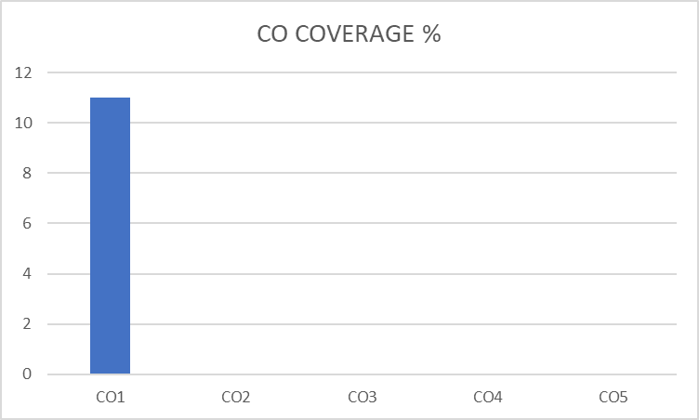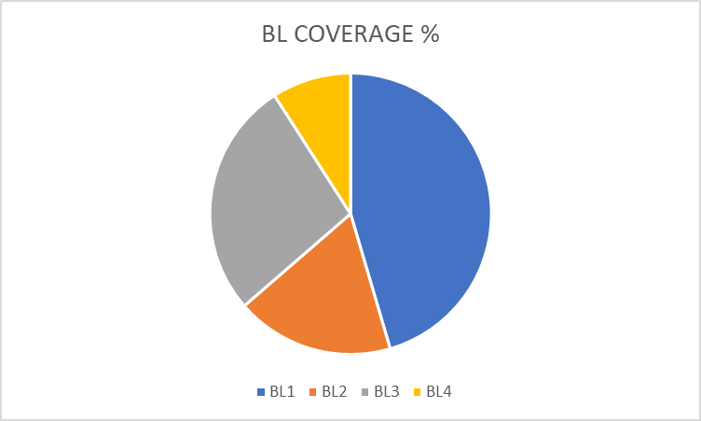

Approved by the Audit Professor/Course Coordinator

